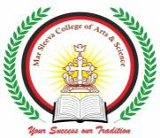MAR SLEEVA COLLEGE OF ARTS AND SCIENCE
MURICKASSERY
DEPARTMENT OF ENGLISH
REPORT OF LEAF ART COMPETITION

As part of Environment day celebration, Department of English organized an interdepartmental Leaf Art Competition on 05th June 2021.
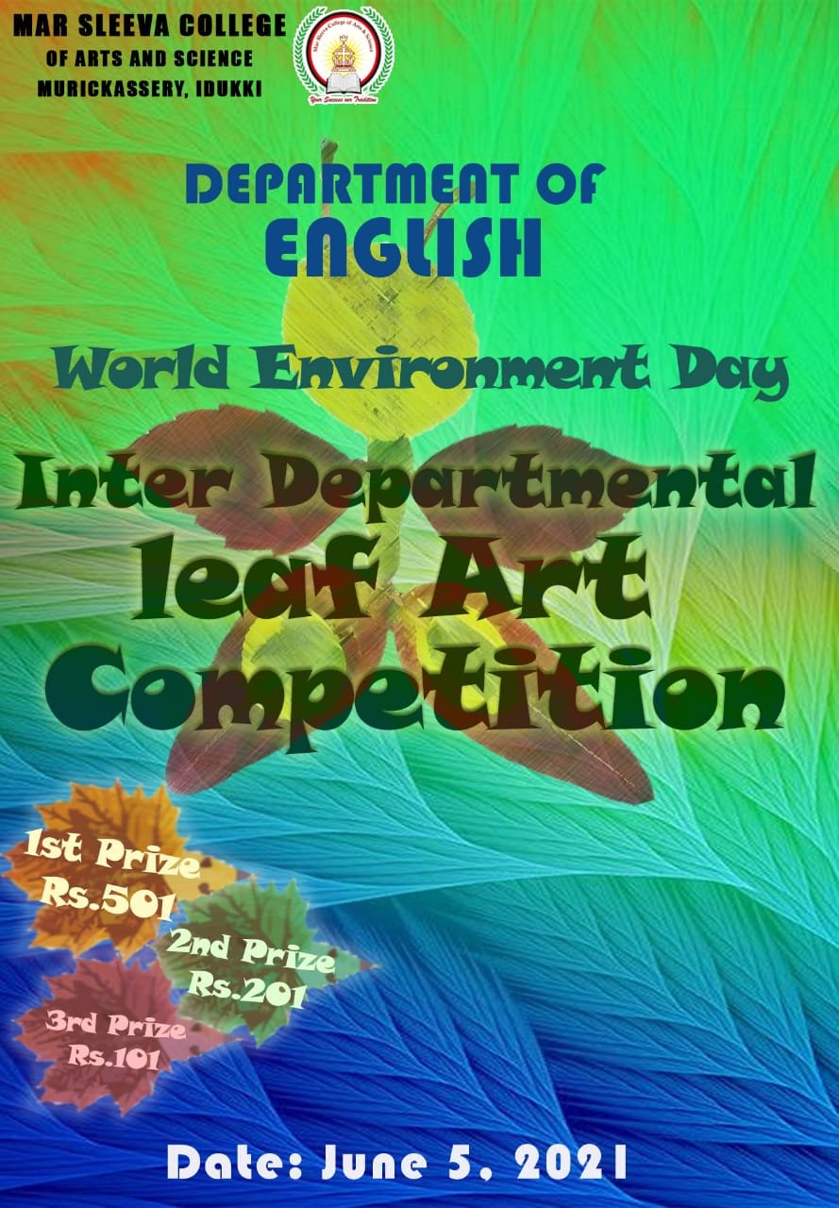
The participants were asked to send their art works on or before 05th June 2021 before 06 PM. The staff and student coordinators shared the rules and regulations of the competition. It was also announced cash prize for the winners.
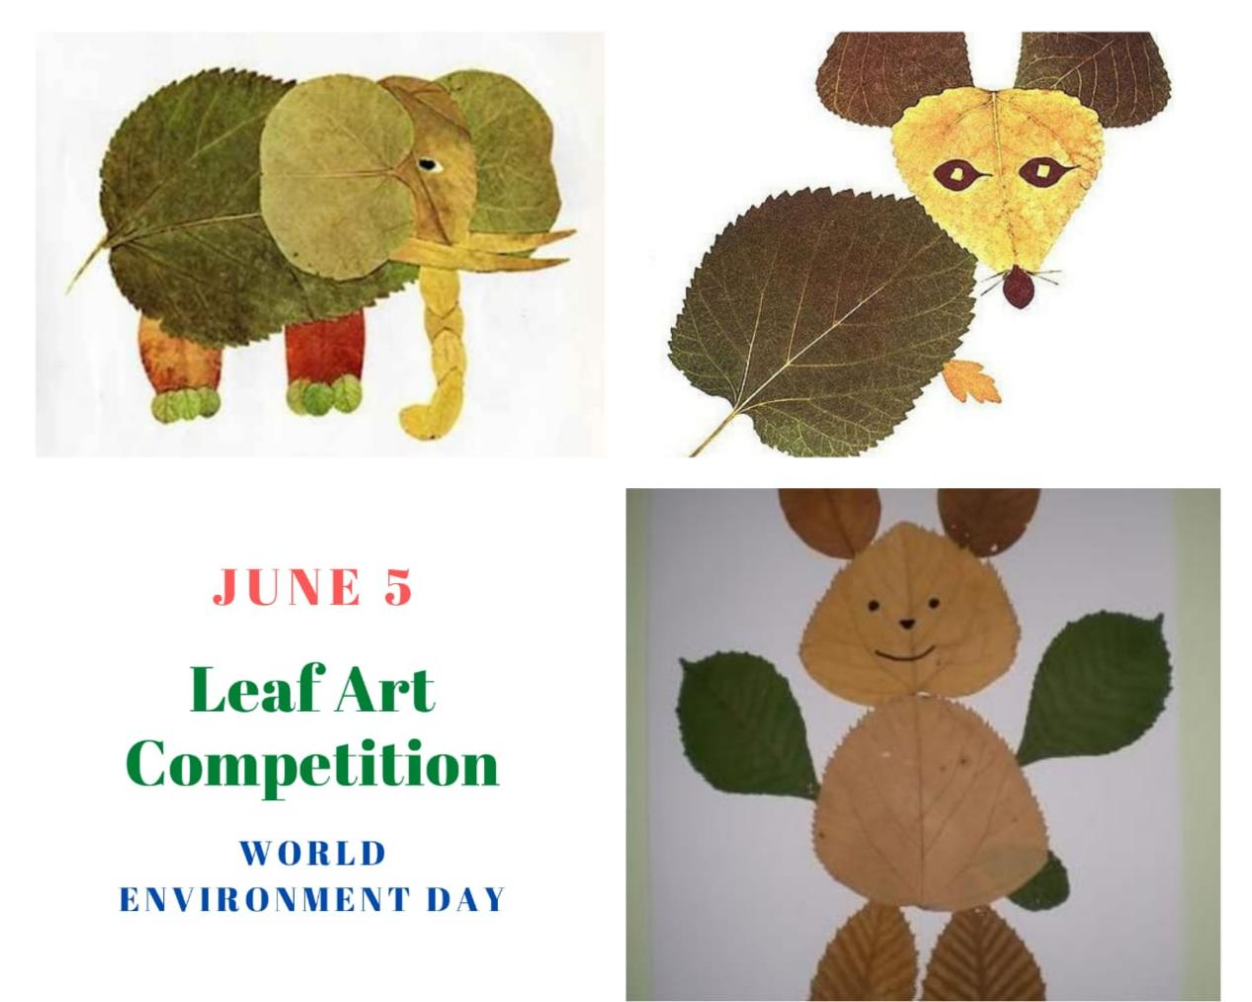
Many students from different departments participated in the competition. The competition was strictly valued on the basis of the creativity of the students. Ms.Maria Susan Jose and Mr.Jobin Joseph were the staff coordinators. Aiwin George and Alfy C Jose served as the student coordinators. Some of the screenshots are attached below:

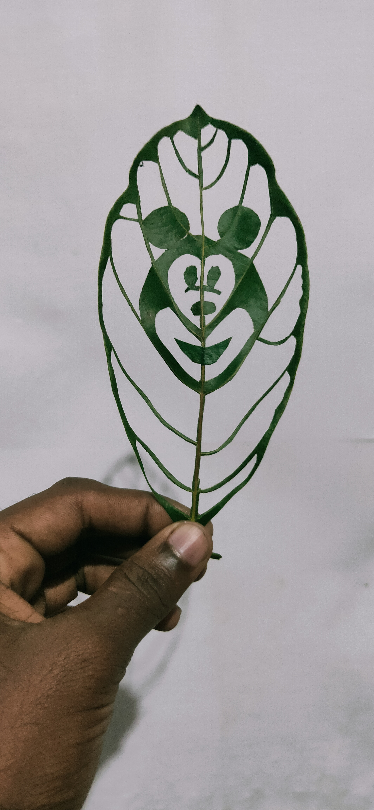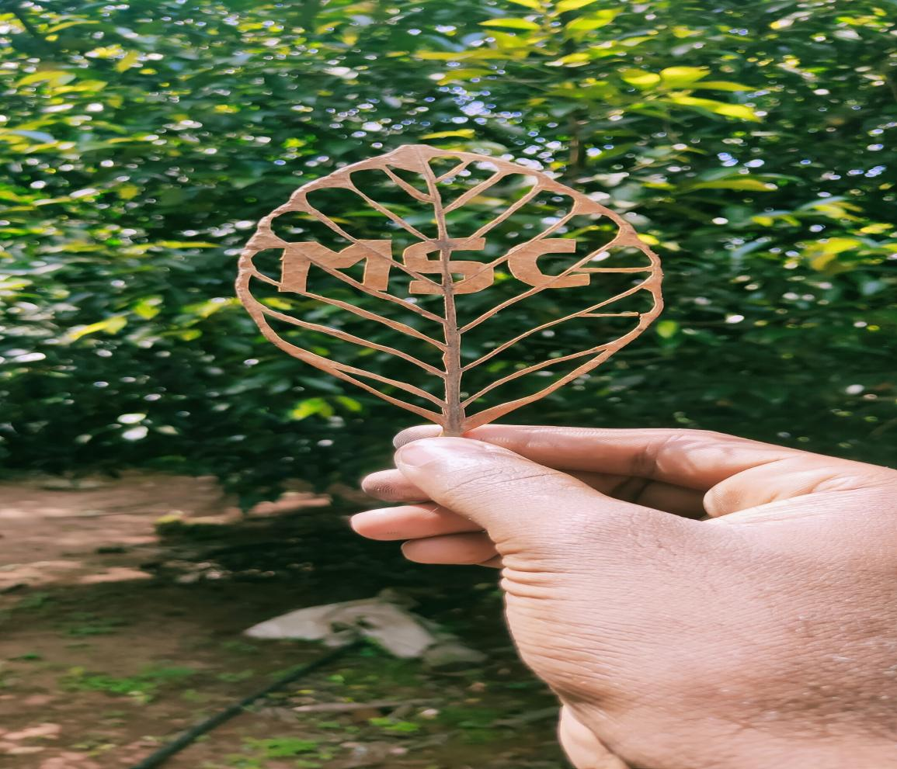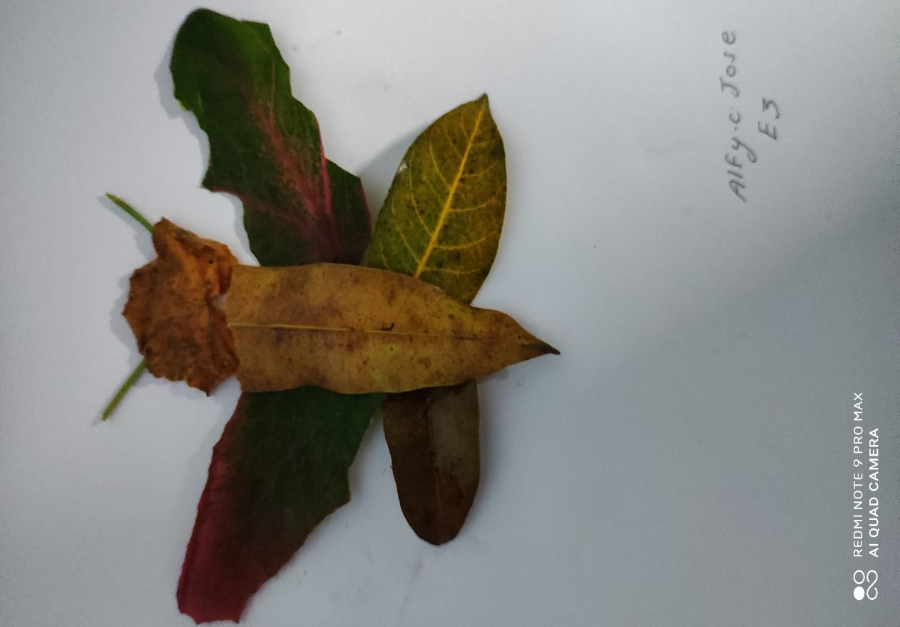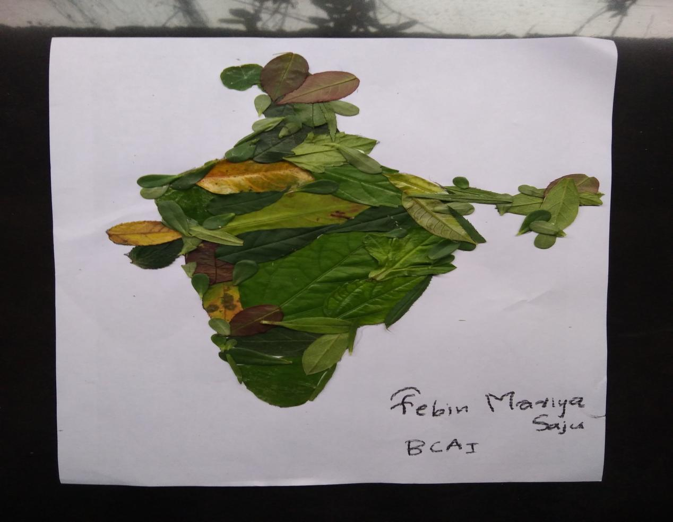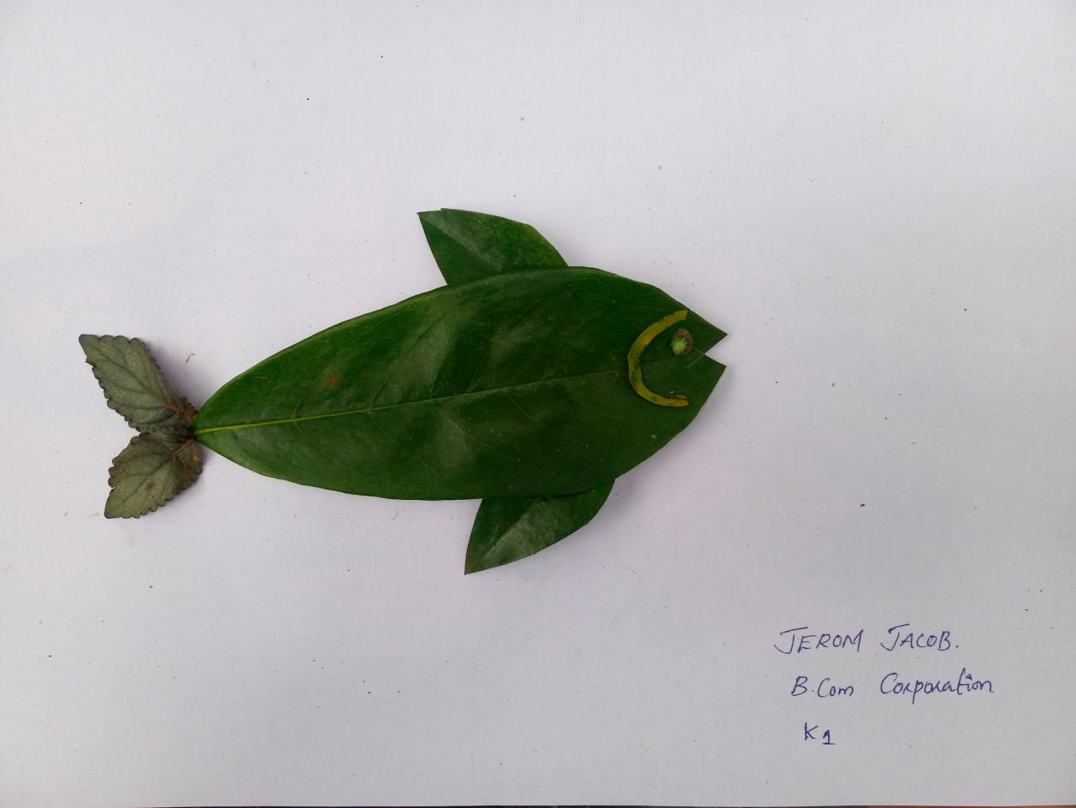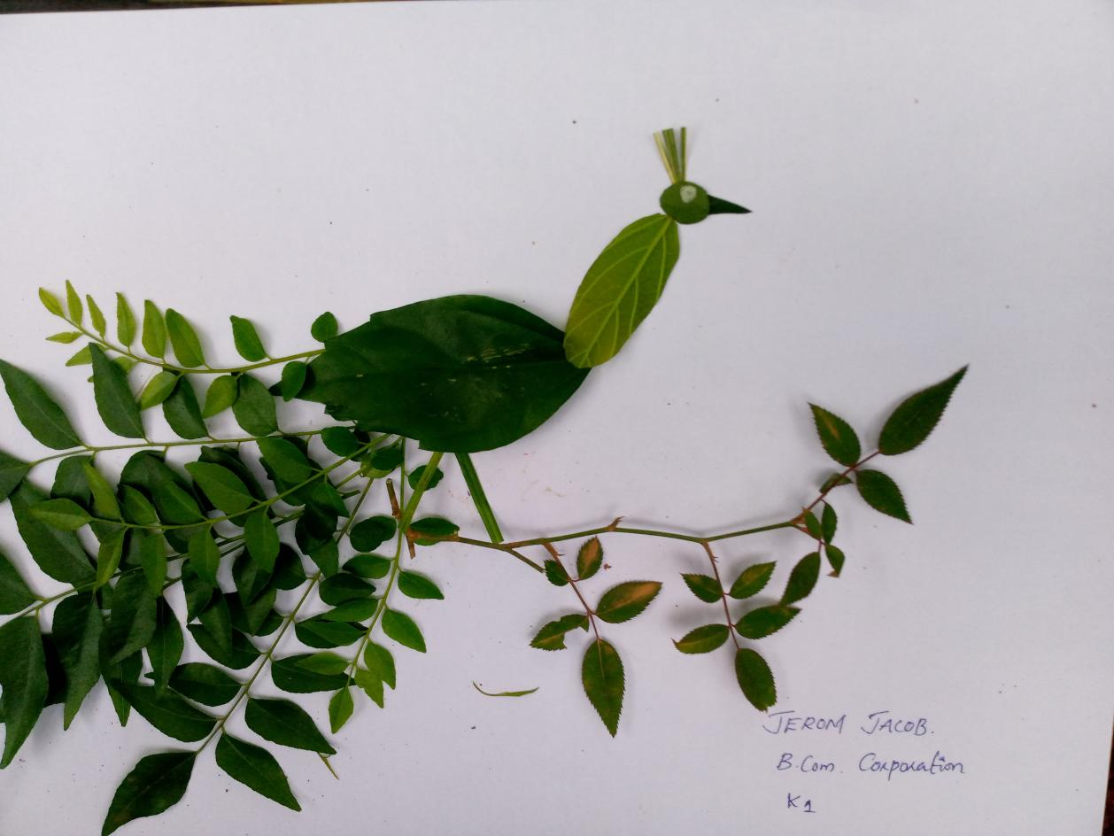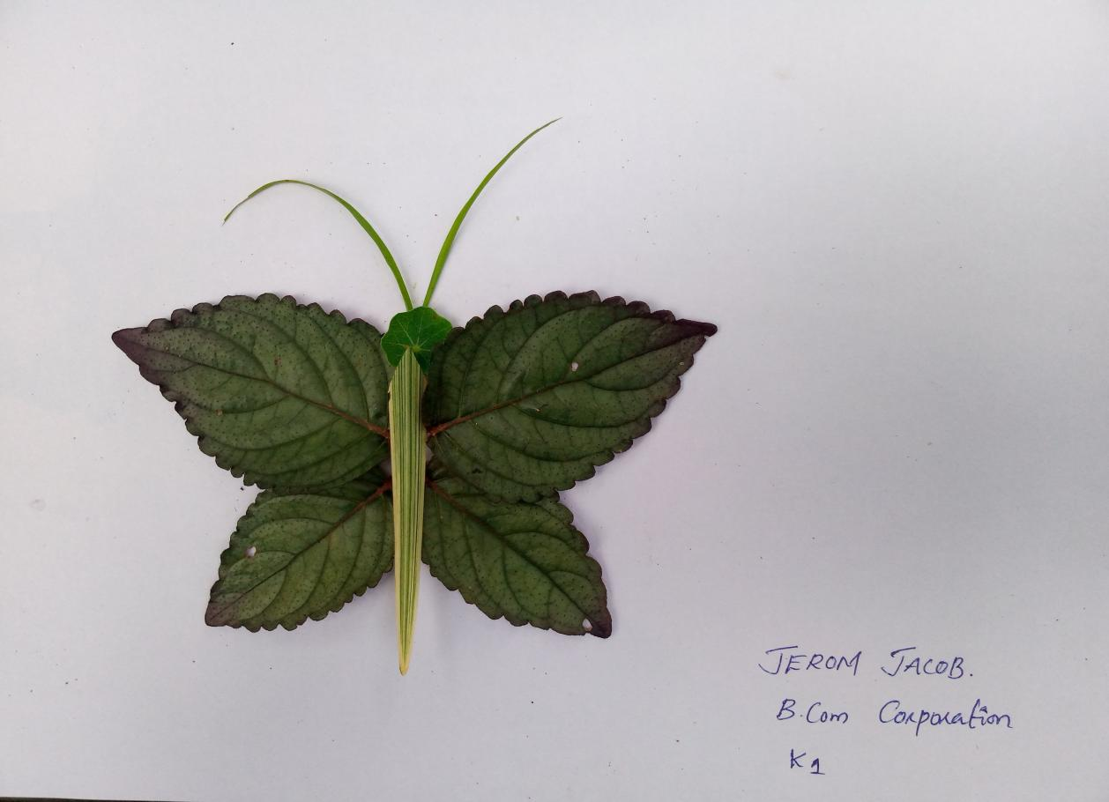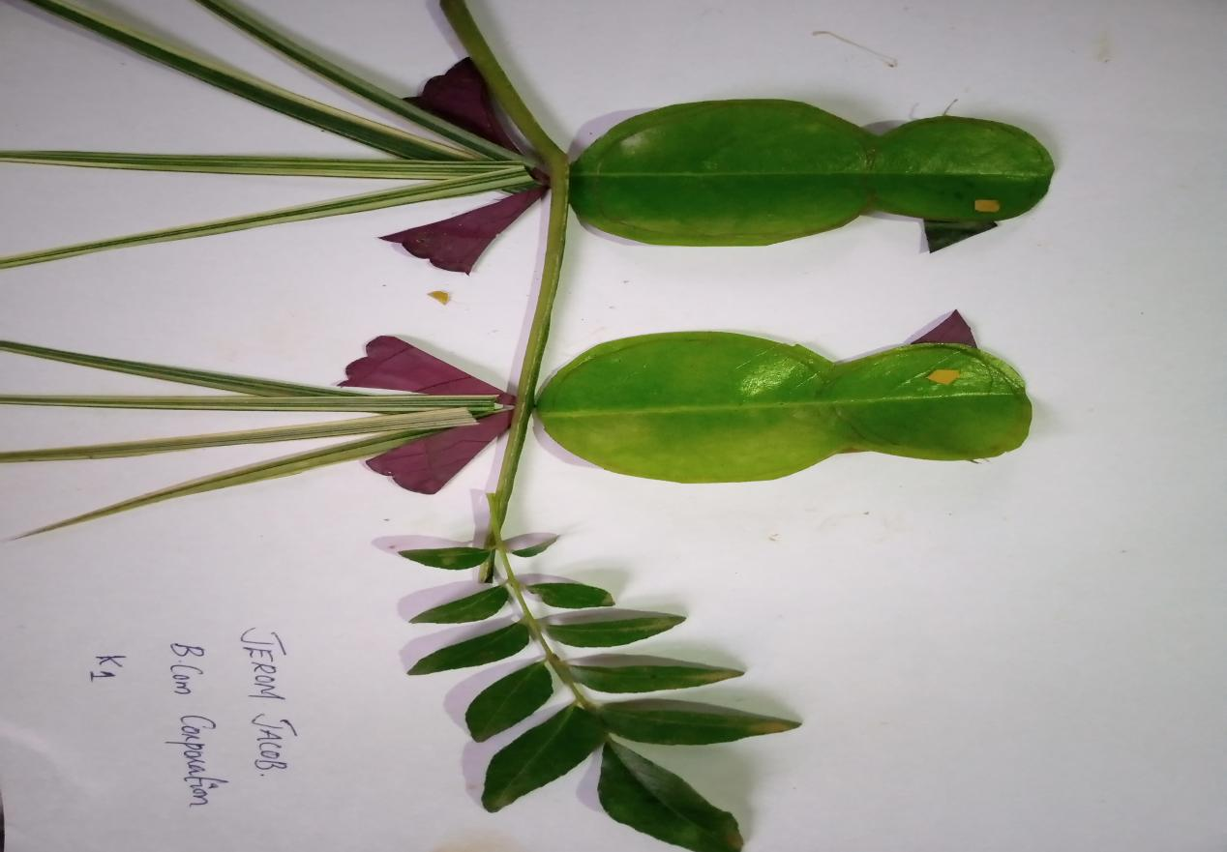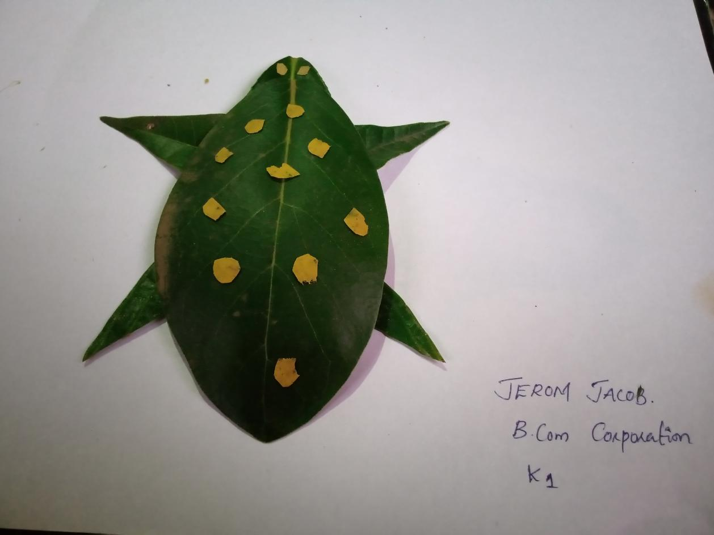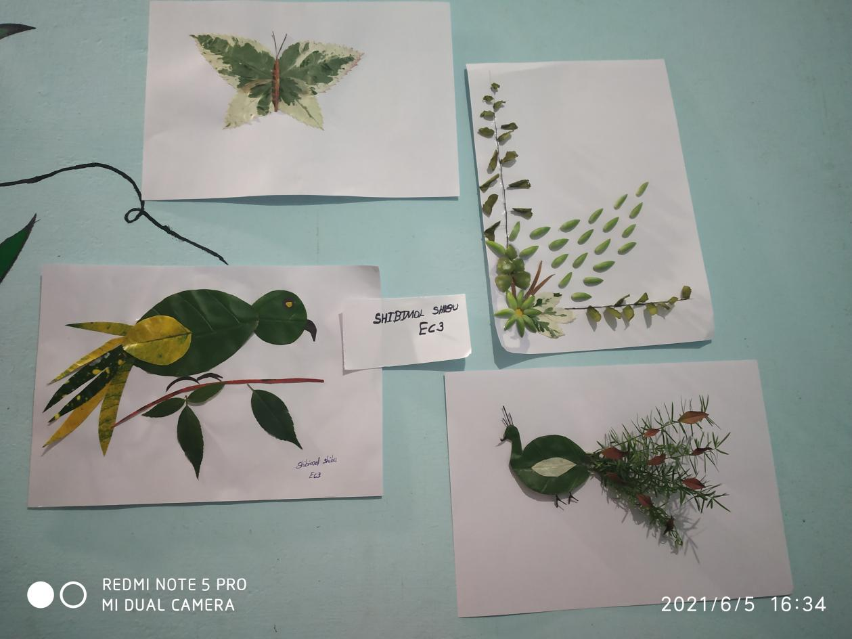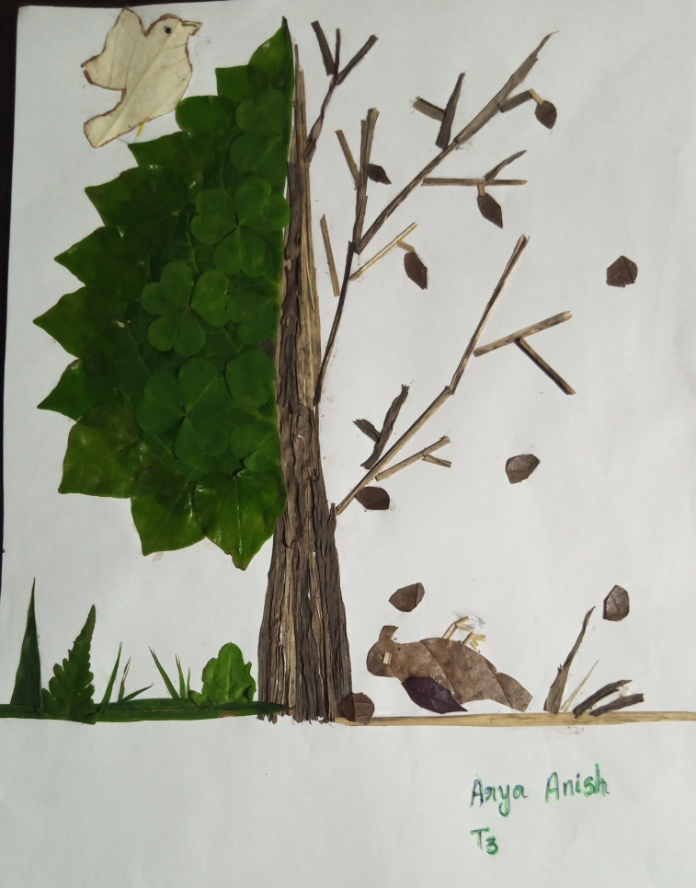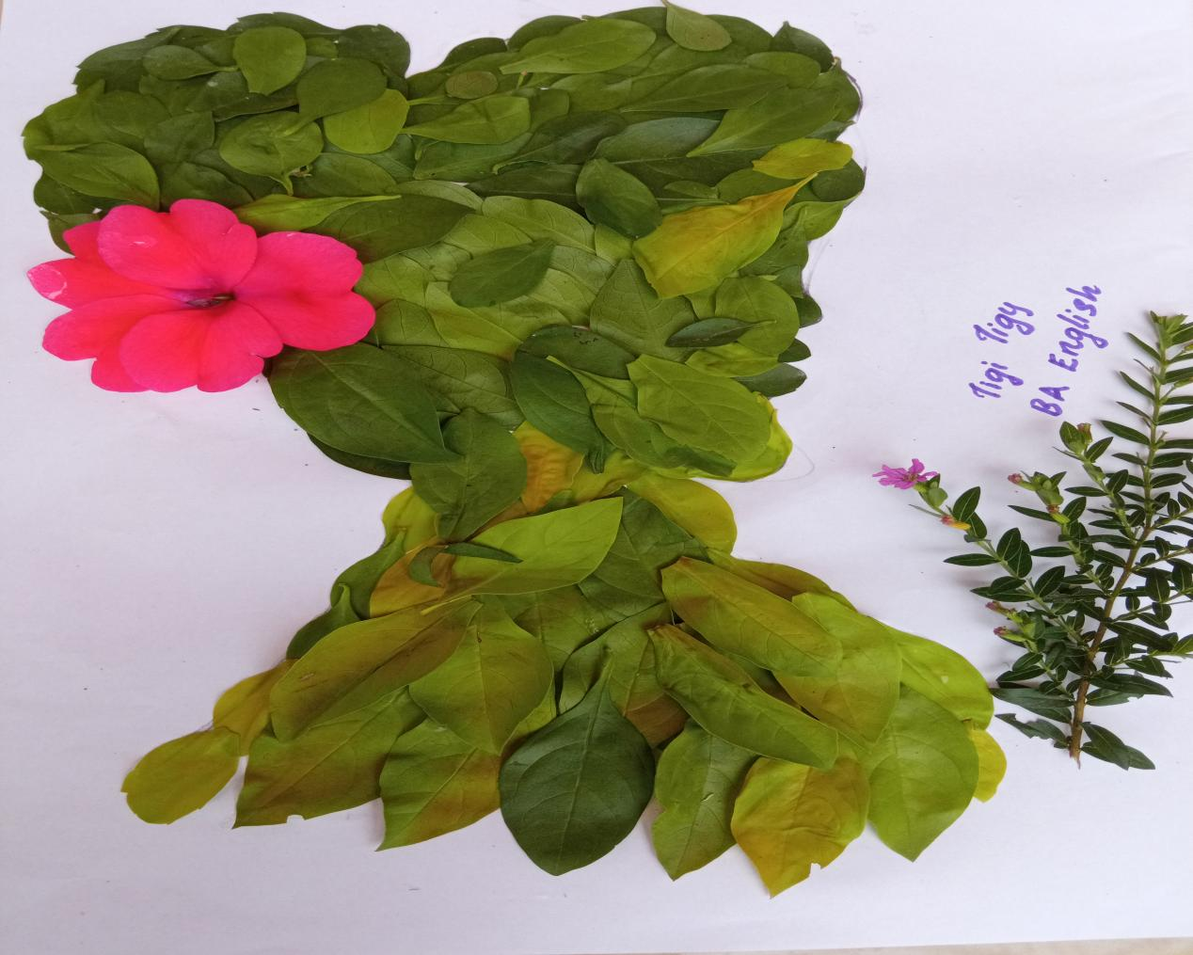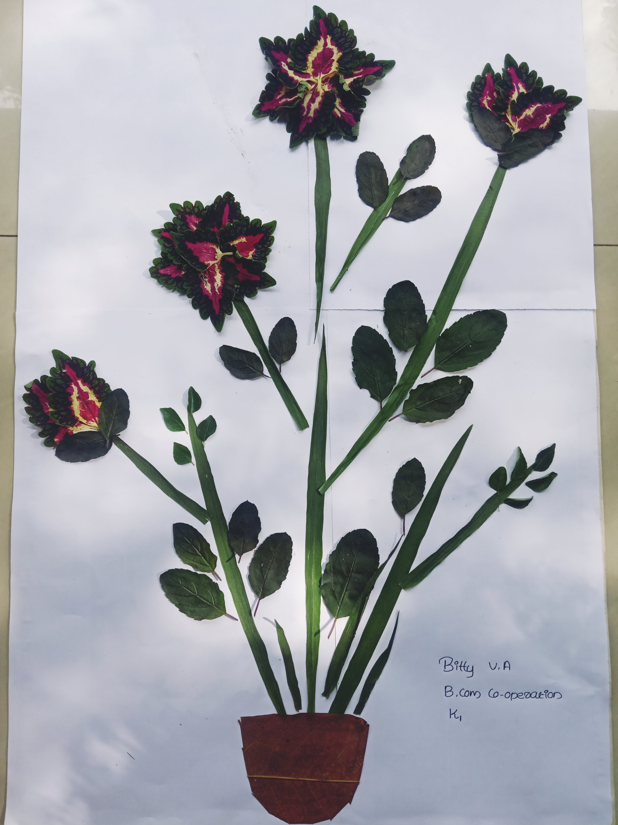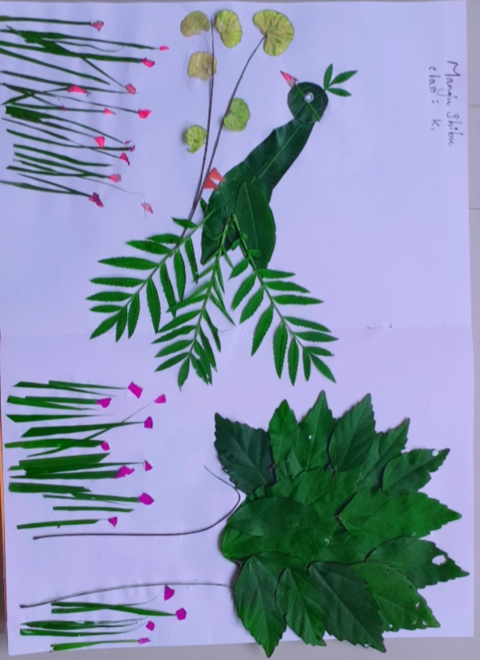

The judgement was based on the creativity of the art work, theme and use of leaves. Mr.Jobin Joseph, Ms.Maria Susan Jose and Ms.Aleena Joseph were the judges of the competition. The Winners of the competition are:
- Arya Anish (T3)
- Jerom Jacob (K2)
- Shibimol Shibi (EC2)
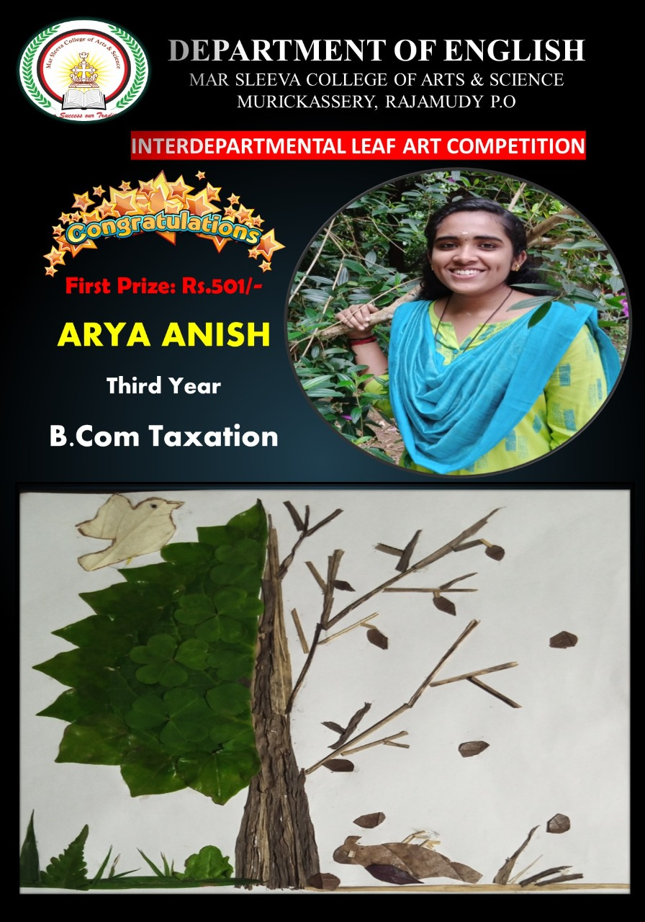
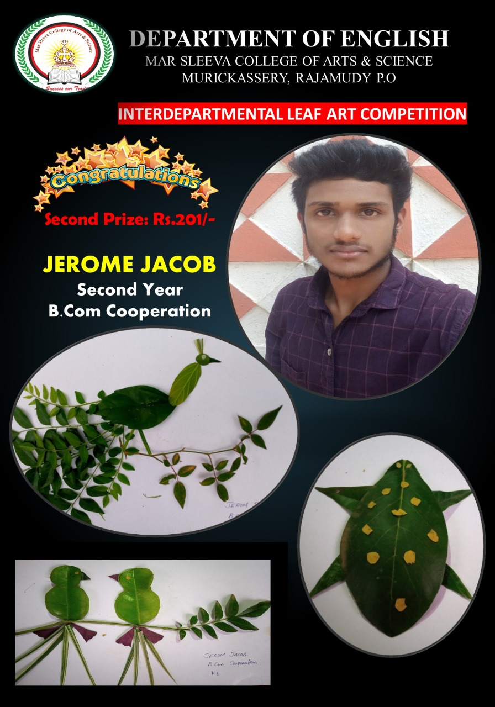

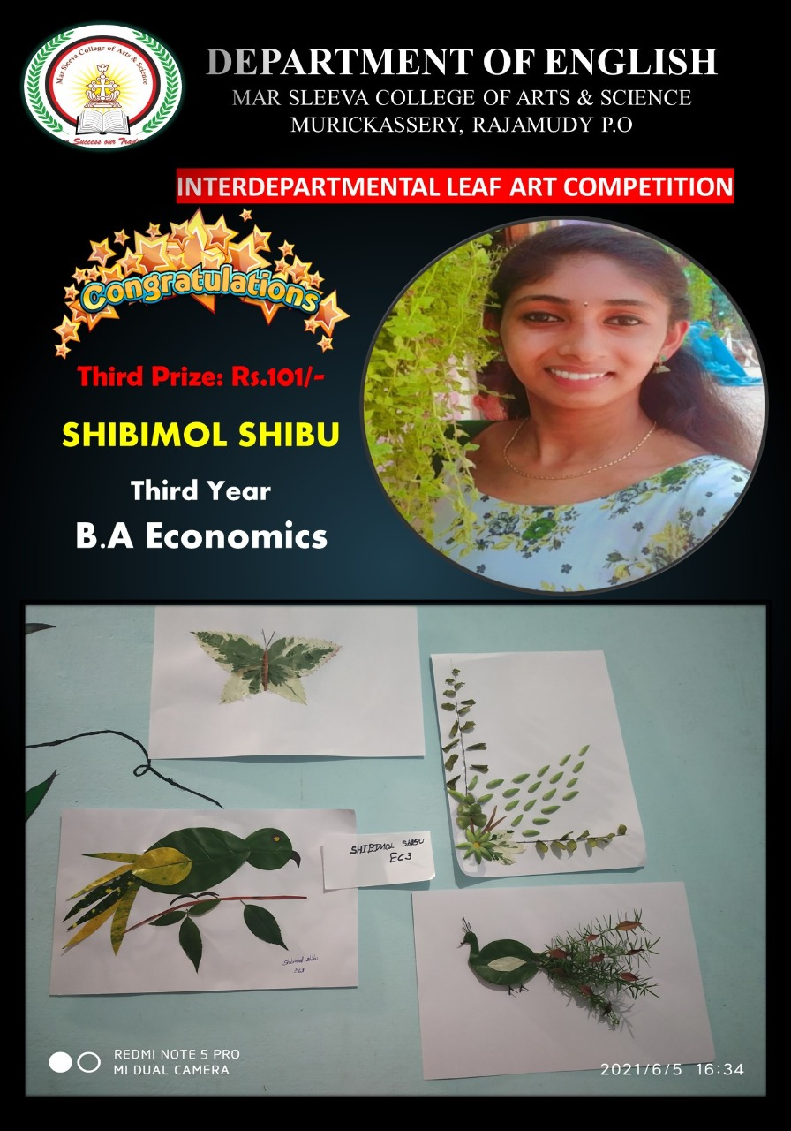
The competition was a different experience for the students. The participants were excited to submit their art works. The effort taken by the participants were highly appreciated.

Signature Signature Signature
Head of The Department IQAC Coordinator Principal

